University of California at Berkeley
College of Engineering
Department of Electrical Engineering and Computer Science

EECS 141: Digital Integrated Circuits - Spring 2006
Report Cover Sheet

TERM PROJECT: SRAM Design Cover Sheet
Report 1 – Memory cell design
Due Monday, March 20, 2006 by 10am in drop box.

Names
Bill Hung
Chih-Chieh (Dennis) Wang

Parameter | Pre-design estimate | Units
Cell area | 13.3632 (928λ²) | µm²
Read noise margin | 250 | mV
Voltage rise during read | 393.6 | mV

GRADE
Approach, result and correctness (60%)
Report (40%)
TOTAL

Table of Content
TERM PROJECT: SRAM Design Cover Sheet 1
Table of Figures 2
PHRASE I Minimize a SRAM Cell 5
Sizing Methodology 5
Pull Up Transistors 5
Access Transistors 5
Pull Down Transistors 6
Read Operation 7
Write Operation 7
HSPICE Stimulation 7
Cadence Layout 8
Phase I Summary 8
Glossary 9
Static Noise Margin HSPICE with Pulldown Transistor Width of 1.2*0.36 1
Read Margin HSPICE Simulation 3
Transient Analysis with switch 7

Table of Figures
Figure 1 High Level SRAM array block diagram 4
Figure 2 SRAM Schematic 5
Figure 3 Read margin and Write margin with W₁ = 0.432um. Read Margin is 450mV, which is larger than the required 400mV. 7
Figure 4 Static Noise Margin VTC HSPICE Plot 1
Figure 5 Read margin VTC 3
Figure 6 Write 0 to q followed by a read 5

SRAM Cell Design

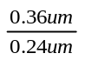
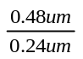
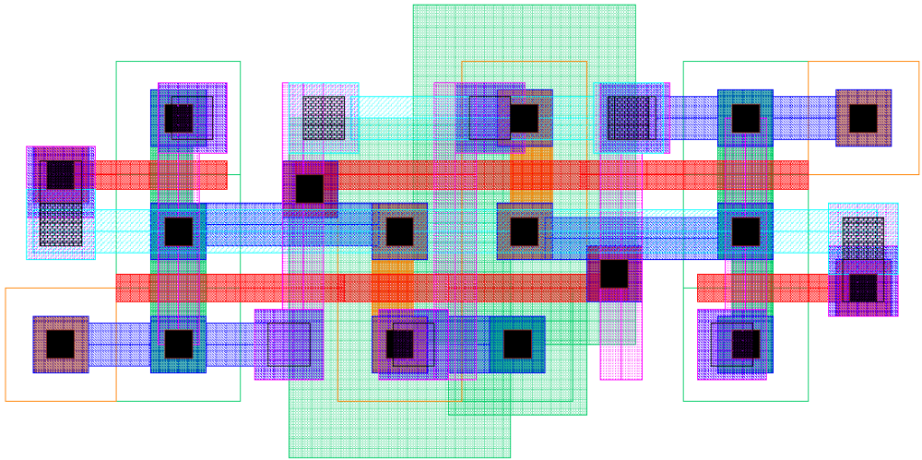
WL
VDD
BL
BL
M1
M2
M3
M4
M5
M6
Q
Cbit
Cbit
Q

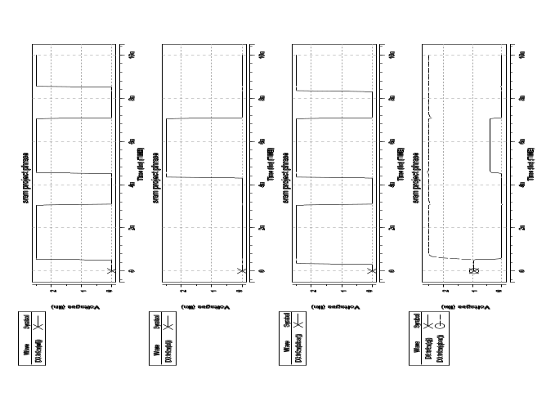
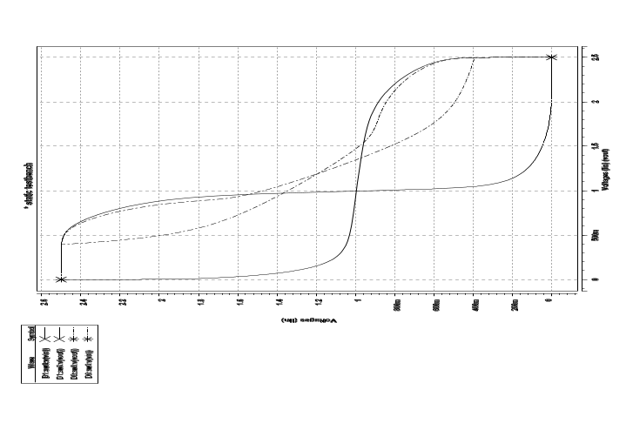
Figure 1: SRAM Cell Schematic
Figure 2: Cadence SRAM Cell Layout
Figure 3: HSPICE Static Noise Margin
Figure 4: HSPICE Read and Write Simulation
(left) The pull-up transistors and the access transistors are minimum sized (W/L=0.36/0.24) to give a pull-up ratio of 1(<1.5). The pull-down transistors are sized W/L=0.48/0.24 to meet the 0.4V read margin. The cell ratio is 1.33(>1.2). (right) The goal of the layout is to make it work with minimum size.
(left) Voltage Transfer Curve (VTC) of an inverter and a half cell taken from the SRAM cell. The read margin of 0.4V is met. Note that the two axises are in different scale. (right) A write simulation wrote a zero into the SRAM cell, followed by a read simulation shows the read margin is below 0.4V. Note that when the word line is low initially, Q and have don’t care values
WL
BL
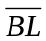
Q and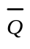
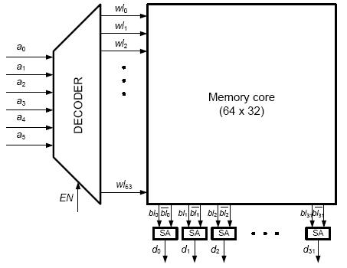
Figure 1 High Level SRAM array block diagram

PHRASE I Minimize a SRAM Cell

The phrase I involes minimizing a SRAM area, stimulating the SRAM design with HSPICE. and drawing the layout for the minimum sized SRAM using Cadence.
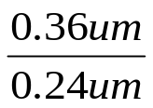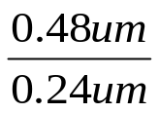
WL
VDD
BL
BL
M1
M2
M3
M4
M5
M6
Q
Cbit
Cbit
Q
Figure 2 SRAM Schematic

Sizing Methodology

Pull Up Transistors
The two pull up transistors (M2 and M4) in Figure 2 are minimum sized. Because the Pull Up ratio between the pull up transistors and the access transistors equals to 1 if they are all minimum sized. The pull-up ratio needs to be less than 1.8 [Rabaey, 661]. From Cadence, the minimum size is when W=0.36um, and L=0.24um.
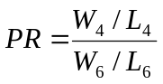 Equation 1:Pull-up Ratio [Rabaey, 661]

Access Transistors
The two access transistors (M5 and M6) in Figure 2 are minimum sized. Practical designs sometimes increase the length (L) of these access transistors to improve the robustness of the SRAM design. Larger L can give less leakage because of longer channel length, but it adds more load to the bit line. In this design, the L of the access transistors are at their minimum lengths. In order to compensate for the minimum lenghts of the access transistors, the width (W) of the pull down transistors are increased.

Pull Down Transistors
The width of the pull down transistors (M1 and M3) is the main parameter to optimize. The goal of the minimizing is to make sure “the SRAM still works” as expected. The critical point to meet the specification to have 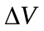 of 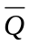 below 0.4V. That is :
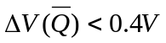. According to the equation
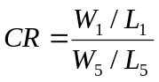 Equation 2:Cell Ratio [Rabaey, 659]
where CR is called t he cell ratio [Rabaey, 659]
CR is about 1.2[Rabaey, 659]. So
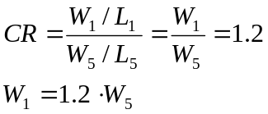
If W₅ is minimum sized, W₁ is 1.2 times the minimum size. As HW3#3a suggested, the minimum NMOS has L=0.24um, and W=0.36um. So,
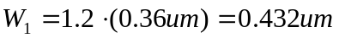
However, with W1 = 0.432um, the read margin exceed the 0.4V specification.
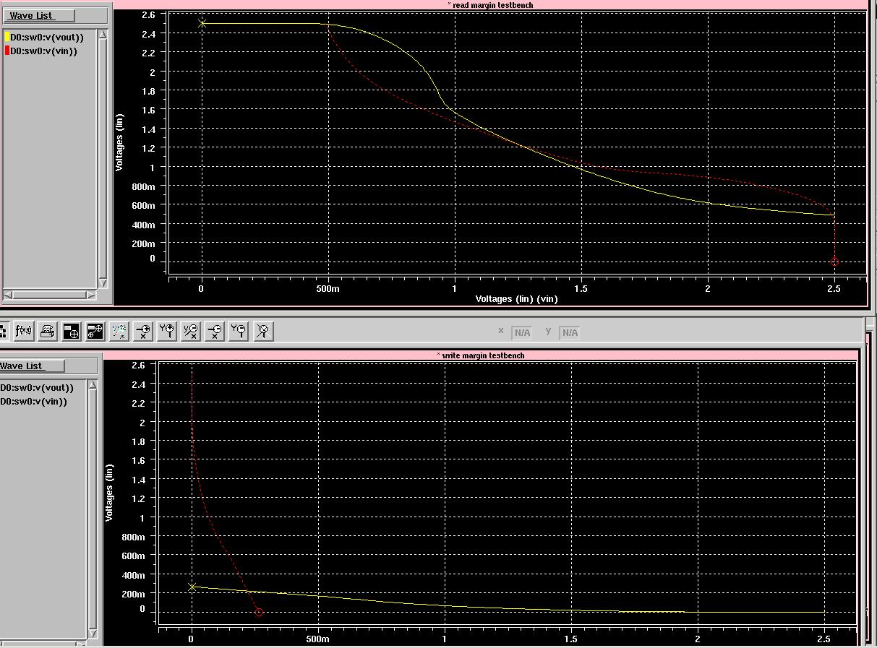
Read Margin 450mV > Required 400mV
Figure 3 Read margin and Write margin with W₁ = 0.432um. Read Margin is 450mV, which is larger than the required 400mV.

Therefore, we increased the width to 0.48um, CR = 1.33, which will gives a read margin 0.3936. A read margin of 0.3936V is better than the required read margin 0.4V.Also note that the width needs to be multiple of lambda in the layout, 0.12um. At this point, both read margin and write margin are below 0.4V. Note that we could increase the width even further to lower the read margin, but since our goal is to minize the size, we used 0.48um.

Read Operation
The read margin has to be met. The read margin is designed so that does not exceed 0.4V during a read operation.

Write Operation
This project needs to meet the write margin. According to Professor Nikolic, the write margin is “the highest voltag on BL/ that writes a zero into the cell”.

HSPICE Stimulation
As we increase the width of the pulldown nmos transistors, the read margin decreases.

Cadence Layout

Phase I Summary

Horizontal Length = 7.2um
Vertical Height = 2.16um
Area = 15.552 um² = 1080λ²

Hours = 39 hours

Glossary
Area
The smallest rectangle enclosing the repetitive pattern. In this case, from a contact of one side to the contact of another side.
Read Margin
is designed so that does not exceed 0.4V during a read operation.
SRAM
Static Random Access Memory
Write Margin
is “the highest voltag on BL/ that writes a zero into the cell

Static Noise Margin HSPICE with Pulldown Transistor Width of 1.2*0.36
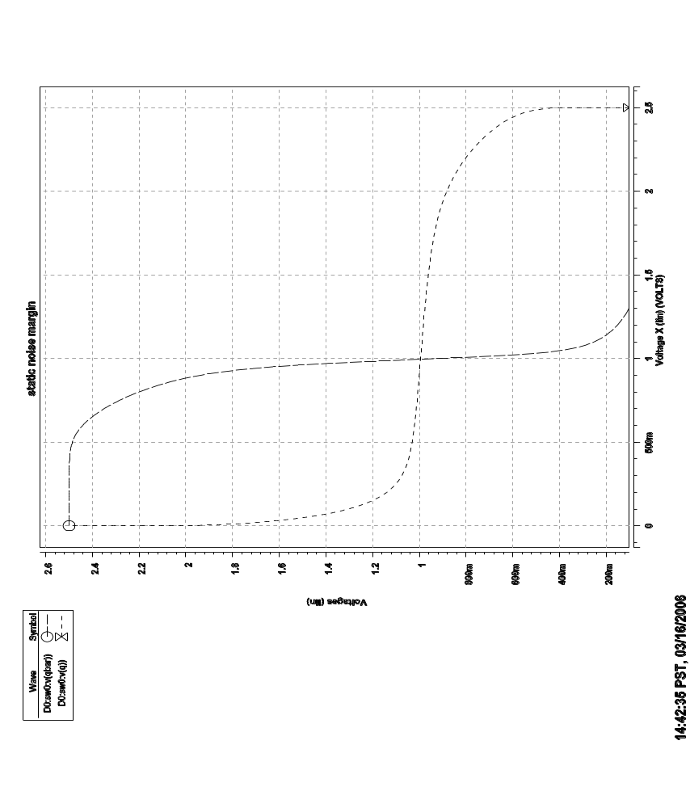
Figure 4 Static Noise Margin VTC HSPICE Plot
Static Noise Margin

.lib '/home/ff/ee141/MODELS/g25.mod' TT

*****************************************
* Parameter
*****************************************
.param vddp=2.5
.param wpulldown=0.36u*1.2
.param pmoswidth=0.36u

*****************************************
* Netlist
*****************************************
VDD vdd 0 'vddp'
vq q 0 2.5V

*M<name> <drain> <gate> <source> <bulk> <model> <geometry>

M1 qbar q 0 0 nmos l=0.24u w='wpulldown'
M2 qbar q vdd vdd pmos l=0.24u w='pmoswidth'

*****************************************
* Analysis
*****************************************
*nomod= no model info from library
.options post=2 nomod

*.op makes hspice determines DC operating point
.op

.dc vq 0 2.5 0.01

.end

Read Margin HSPICE Simulation

Figure 5 Read margin VTC

** inverter subcircuit
.subckt my_inv vin vout vdd vss
.param wpulldown='0.48u'
.param pmoswidth=0.36u
M1 vout vin vss vss nmos l=0.24u w='wpulldown'
M2 vout vin vdd vdd pmos l=0.24u w='pmoswidth'
.ends

* read margin testbench
.lib '/home/ff/ee141/MODELS/g25.mod' TT
.inc 'circuit.sp'
Vdd vdd 0 2.5
Vin VIN 0 dc 2.5
xinv Vin Vout vdd 0 my_inv
M5 vblbar vdd Vout 0 nmos l=0.24u w=0.36u
Vblbar vblbar 0 2.5
.dc Vin 0 2.5 0.01
.option post
.END

$DATA1 SOURCE='HSPICE' VERSION='V-2004.03 '
.TITLE 'sram project phrase'
q_max_rd q_max_wr temper alter#
1.886e-02 0.3936 25.0000 1.0000

* Write margin testbench (not required for the report)
.lib '/home/ff/ee141/MODELS/g25.mod' TT
.inc 'circuit.sp'
Vdd vdd 0 2.5
Vin VIN 0 dc 2.5
xinv Vin Vout vdd 0 my_inv
M6 vbl vdd Vout 0 nmos l=0.24u w=0.36u
Vbl vbl 0 0
.dc Vin 0 2.5 0.01
.option post
.END

Figure 6 Write 0 to q followed by a read

SRAM PROJECT PHRASE

.lib '/home/ff/ee141/MODELS/g25.mod' TT

*****************************************
* Parameter
*****************************************
.param vddp=2.5
.param vwl=2.5
.param vbl=0
.param vblbar=0
* find the optimal nmos width
.param w = 1.32
.param wpulldown='0.48u'
.param pmoswidth=0.36u
* increase the size of capacitance
.param cright=.5pF
.param cleft=.5pF

*****************************************
* Netlist
*****************************************
*M<name> <drain> <gate> <source> <bulk> <model> <geometry>
M1 qbar q 0 0 nmos l=0.24u w='wpulldown'
M2 qbar q vdd vdd pmos l=0.24u w='pmoswidth'
M3 q qbar 0 0 nmos l=0.24u w='wpulldown'
M4 q qbar vdd vdd pmos l=0.24u w='pmoswidth'
M5 qbar wl blbar 0 nmos l=0.24u w=0.36u
M6 q wl bl 0 nmos l=0.24u w=0.36u

VDD vdd 0 'vddp'
*VWL wl 0 'vwl'

* generate pulses for word line and bit lines. In the first cycle, write * a zero to q; in the second cycle, read 0 from q
VWL wl 0 pulse(0 2.5 .5n 0.05n 0.05n 2.5n 4n)
VBLBAR blbar 0 pulse(0 2.5 .3n 0.05n 0.05n 2.7n 4n)
VBL bl 0 pulse(0 2.5 4.3n 0.05n 0.05n 2.7n 8n)

Cblbar blbar 0 'cleft'
Cbl bl 0 'cright'

*****************************************
* Analysis
*****************************************
.options post=2 nomod
.op

.tran 0.01ns 10ns *sweep w 1.08 1.8 .06
* In both scenarios, we want to check the maximum voltage at q
.meas q_max_wr max v(q) from=.6n to=3.5n
.meas q_max_rd max v(q) from=4.6n to=7.5n

.END

Transient Analysis with switch
SRAM PROJECT PHRASE

.lib '/home/ff/ee141/MODELS/g25.mod' TT

*****************************************
* Parameter
*****************************************
.param vddp=2.5
.param vwl=2.5
.param vbl=0
.param vblbar=0
* find the optimal nmos width
.param w = 1.32
.param wpulldown='0.48u'
.param pmoswidth=0.36u
* increase the size of capacitance
.param cright=.5pF
.param cleft=.5pF

*****************************************
* Netlist
*****************************************
*M<name> <drain> <gate> <source> <bulk> <model> <geometry>
M1 qbar q 0 0 nmos l=0.24u w='wpulldown'
M2 qbar q vdd vdd pmos l=0.24u w='pmoswidth'
M3 q qbar 0 0 nmos l=0.24u w='wpulldown'
M4 q qbar vdd vdd pmos l=0.24u w='pmoswidth'
M5 qbar wl blbar 0 nmos l=0.24u w=0.36u
M6 q wl vx 0 nmos l=0.24u w=0.36u

* syntax for ideal switch: G1 node1 node2 VCR PWL(1) node3 V Resistance
* V Resistance, where node3 is the controlling voltage. For example, the
* syntax below said that the switch is controlled by phi1; if it is 0V,
* the off resistance is 100Gohm; if it is 2.5V, the on resistance is 1uohm
G1 vx bl VCR PWL(1) phi1 0 0,100G 2.5,1u
*G2 vx 0 VCR PWL(1) phi1 0 0,100G 2.5,1u
* controlling voltage source
Vphi1 phi1 0 pwl(0 0 .4n 0 0.4000001n 2.5 4.4n 2.5 4.4000001n 0 )

VDD vdd 0 'vddp'
*VWL wl 0 'vwl'

* generate pulses for word line and bit lines. In the first cycle, write
* a zero to q; in the second cycle, read 0 from q
VWL wl 0 pulse(0 2.5 .5n 0.05n 0.05n 2.5n 4n)
VBLBAR blbar 0 pulse(0 2.5 .3n 0.05n 0.05n 2.7n 4n)
VBL bl 0 pulse(0 2.5 4.3n 0.05n 0.05n 2.7n 8n)

Cblbar blbar 0 'cleft'
Cbl bl 0 'cright'

*****************************************
* Analysis
*****************************************
.options post=2 nomod
.op

.tran 0.01ns 10ns *sweep w 1.08 1.8 .06
* In both scenarios, we want to check the maximum voltage at q
.meas q_max_wr max v(q) from=.6n to=3.5n
.meas q_max_rd max v(q) from=4.6n to=7.5n

.END

